Model – BM 1.0
User Manual



Master Bell System – Key Features
- Automatic Daily Bell Scheduling
- Supports up to 20 programmable bell times per day.
- Custom Track Playback
- Each bell can play a unique MP3 track from USB or SD card.
- Track selection via track code (001 to 099) matching audio file name (e.g., 001.mp3).
- Repeat Count Setting
- User-defined repeat count for each bell (minimum 1 repeat).
- Real-Time Clock (RTC)
- Built-in DS3231 RTC for accurate and consistent timekeeping, even during power failures.
- EEPROM Memory Storage
- Stores all bell times, track codes, and settings permanently—no data loss on power off.
- User-Friendly Interface
- Easy navigation using UP, DOWN, LEFT, RIGHT buttons.
- Settings displayed on 16x2 LCD screen with blinking area for editing.
- Built-in Audio Amplifier
- Powered by a 24V 2.5A supply, driving external speakers (SPK1 & SPK2 terminals).
- Optional line-out for external amplifier connection.
- Multiple Output Options
- Connect speakers directly via SPK1/SPK2 or route audio to external amp.
- USB/SD Card Compatible
- Supports FAT32-formatted USB drives/SD cards, plug & play.
- Manual Control Option
- Optional manual trigger for instant bell or test play.
- Reliable and Durable Design
- Operates in 0°C to 50°C environment, ideal for schools, colleges, and institutions.
- Compact, wall-mountable enclosure with power safety feature

22VAC
SPK2
SPK1
LCD Display
Volume Control
USB Drive Connection
Audio Output for External Amplifier
Amplifier Volume Control knob
Main Switch

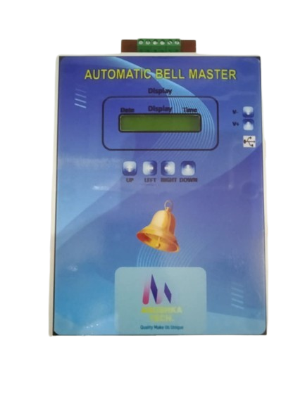

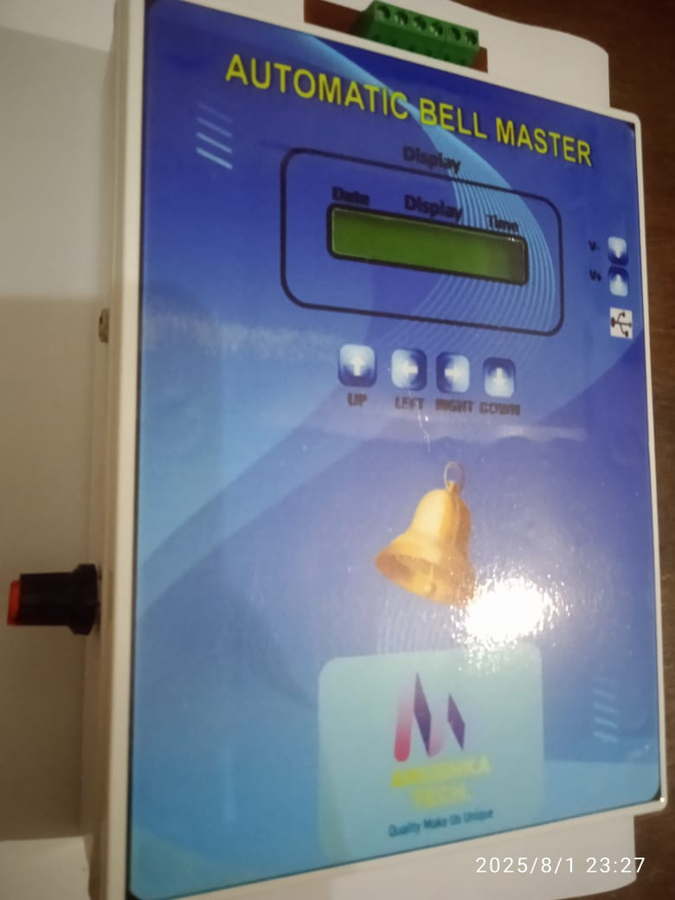

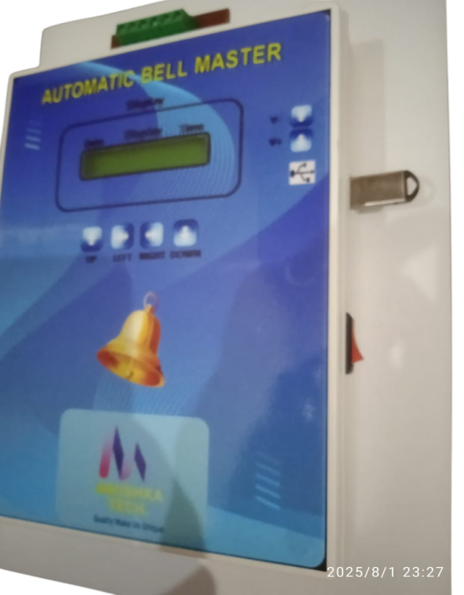

Push Button for Setting and Navigate through Menu
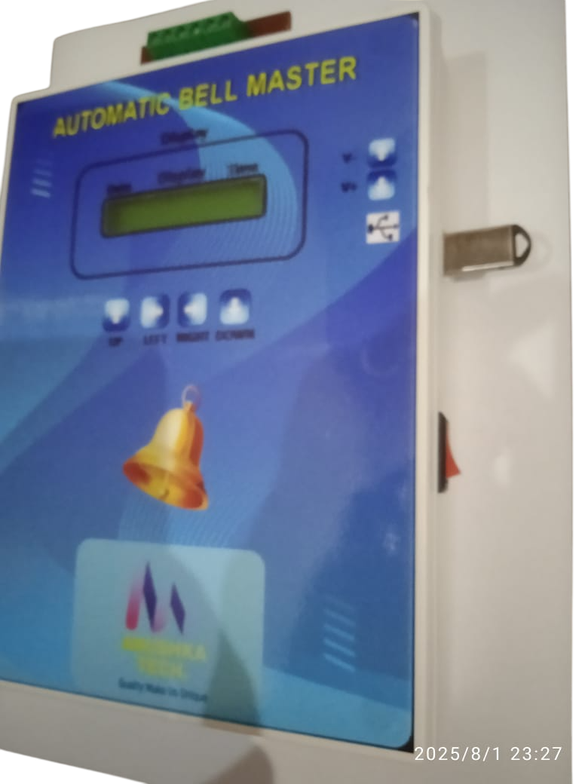



Mains Switch:
Use the mains switch to turn the entire system ON or OFF. Ensure the switch is in the OFF position before performing any maintenance or installation activities.
Switch on device and wait for (Approx 2 to 3 second) for initialization.

Navigation and Setting Key (Push Button):
Use the UP, DOWN, LEFT, and RIGHT buttons to navigate through the menu options and change settings:
UP/DOWN: Scroll through menu items or increase/decrease values.
LEFT/RIGHT: Move between settings fields or toggle between options.

Audio Output for External Amplifier:
This device provides a line-level audio output for connection to an external amplifier. Use a 3.5mm stereo jack or RCA connectors (as applicable) to connect the audio output to the amplifier’s input. Ensure the amplifier is powered off during connection to avoid noise or damage.
Note: This is not a speaker-level output. Connect only to amplifier input, not directly to speakers.

Volume Control Knob:
Use the Volume Control Knob to adjust the output sound level of the amplifier. Turn the knob clockwise to increase the volume and counter clockwise to decrease it.
Note: set the volume to a low level before powering on the amplifier to avoid sudden loud output.

Volume Control Push Button:
Use the Volume Control button to adjust the output sound level of audio level output.

USB Drive Connection:
Insert a USB flash drive into the USB port to play audio files directly. The system supports MP3 and other common audio formats.
Once connected, the device will automatically detect the drive and begin playback. Use the navigation buttons to browse tracks if supported.
Note: Use only standard USB drives (FAT32 format) up to 32GB for best compatibility. Do not remove the USB drive while playing.

SPK1 and SPK2 Terminals:
Connect external speakers to the SPK1 and SPK2 terminals. These are outputs from the built-in amplifier.
Ensure speaker impedance is 8Ω.(MAX watt 50W)
Connect the speaker wires firmly: positive (+) to + terminal and negative (–) to – terminal on each speaker.
Note: Power off the system before connecting or disconnecting speakers to avoid damage.

220V AC Power Input Terminal:
Connect the device to a 220V AC mains supply using the designated terminal block. Ensure correct wiring:
Note: Always disconnect the power before wiring.
Note: Only qualified personnel should handle AC connections to avoid the risk of electric shock.

Menu Navigation and Setting:
- Press left button for System Setting
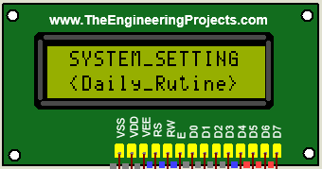
- Use the navigation buttons (UP/DOWN) to scroll through Menu and right button for selection.
Track Code
A- Daily Routing:
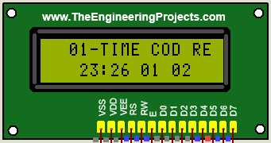
Bell Time & Track Setup Instructions:
Time: HH:MM
Repeat Count
Use the navigation buttons (UP/DOWN) to change the value in the blinking area.
After setting the value, press the RIGHT button to save the selection.
For each bell:
Select a track code (e.g., 001 to 099) that matches the audio file stored in the USB or SD card.
Set a track repeat count if needed. The minimum repeat count should be 1.
Note: Ensure all track files (e.g., 001.mp3, 002.mp3) are properly named and located in the root directory of the USB/SD card.

Bells will automatically ring at the scheduled times with the selected track.
You can set up to 20 bells per day, each with a custom time and associated track code and repeat count
B- Special Date:
Select the spacial date setting menu from the list.
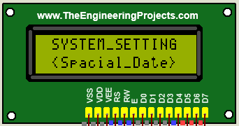
Use the navigation buttons (UP/DOWN) to change the value in the blinking area.
After setting the value, press the RIGHT button to save the selection.
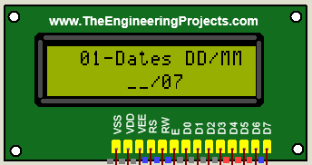
Special Date: Date/Month

You can set up to 10 date max, which have different schedule from the normal days.
C- Special Bell:
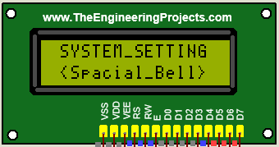
Select the spacial Bell setting menu from the list.
Use the navigation buttons (UP/DOWN) to change the value in the blinking area.
After setting the value, press the RIGHT button to save the selection.
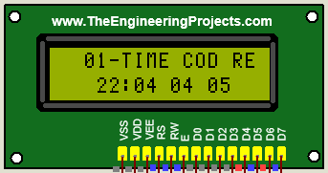
Repeat Count
Special Bell time: HH:MM

Track Code

You can set up to 10 Bell max, which have different schedule from the normal days.
D- Week Day and Week off Selection Setting:
Select the System Day setting menu from the list.
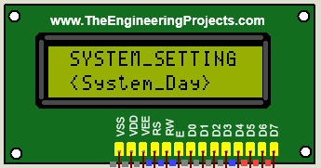

Use the navigation buttons (UP/DOWN) to change the value in the blinking area.
After setting the value, press the Left button to save the selection.

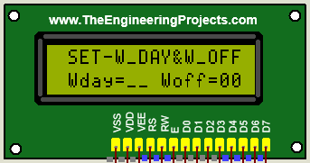
Week of the Day Setting:
1-Monday
2-Tuesday
3-Wednesday
4-Thursday
5-Friday
6-Saturday
7-Sunday

Week of the Day Setting:
- Monday
- Tuesday
- Wednesday
- Thursday
- Friday
- Saturday
- Sunday

Note: Set corresponding digit (1-7) for week of day and Week off selection.

E- System Time:
Select the System Time setting menu from the list.
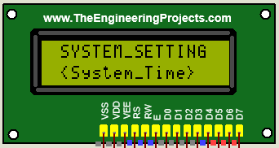
Use the navigation buttons (UP/DOWN) to change the value in the blinking area.
After setting the value, press the Left button to save the selection.
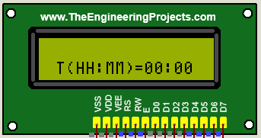
E- System Date:
Select the System Time setting menu from the list
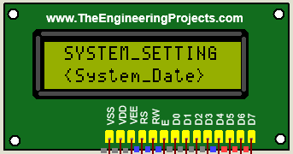
Use the navigation buttons (UP/DOWN) to change the value in the blinking area.
After setting the value, press the Left button to save the selection.
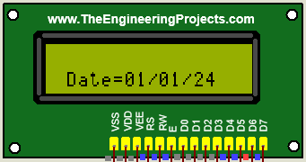

Track Name | Code | Entry Code |  | Track Name | Code | Entry Code
0000-Zeroth-Period | 0000 | 01 |  | 0013-Thirteen-period | 0013 | 14
0001-Frist-period | 0001 | 02 |  | 0014-Fourteen-period | 0014 | 15
0002-Second-period | 0002 | 03 |  | 0015-Fifteen-period | 0015 | 16
0003-Third-period | 0003 | 04 |  | 0016-Assembly | 0016 | 16
0004-Fourth-period | 0004 | 05 |  | 0017-lunch-time | 0017 | 17
0005-Fifth-period | 0005 | 06 |  | 0018-School-Close | 0018 | 18
0006-Sixth-period | 0006 | 07 |  | 0019-EGB | 0019 | 19
0007-Seventh-period | 0007 | 08 |  | 0020-Gong-Bell | 0020 | 20
0008-Eight-period | 0008 | 09 |  | 0021-Siren | 0021 | 21
0009-Ninth-period | 0009 | 10 |  | 0022-Jana-Gana-Mana | 0022 | 22
0010-Tenth-period | 0010 | 11 |  | 0023-Vande Mataram | 0023 | 23
0011-Eleventh-period | 0011 | 12
0012-Twelve-period | 0012 | 13

Specifications:
Power Supply | 220V AC input (internal 24V DC, 2.5A regulated for amplifier)
Bell Output | Audio output via built-in amplifier (up to 50W total)
Speaker Output Terminals | SPK1 and SPK2 , 4–8Ω compatible
Audio Source | USB Drive / SD Card (supports MP3 format, 001.mp3 to 099.mp3)
Track Selection | Individual track code (001–099) per bell schedule
Track Repeat Option | Selectable repeat count per bell (min. 1 time)
Number of Bells | Up to 20 bell times per day
Real-Time Clock (RTC) | DS3231 high-accuracy timekeeping module
Memory Backup | EEPROM storage for all bell schedules and settings
Display | 16x2 LCD for time and menu navigation
Navigation Buttons | UP, DOWN, LEFT, RIGHT for setting time and bell schedules
Output for External Amp | Line-level audio out (optional)
Enclosure | Wall-mountable, metal/plastic casing (customizable)
Operating Temperature | 0°C to 50°C
Dimensions | [8X6X2.5]inches
Weight | [400]gram

Anushka Tech.
Customer Support +91-8840675624
Email:mohan.sharma2004@gmail.com



